
Dashboard Design

Date | 24 August 2026
Team ID | Individual
Project Name | India's Agricultural Crop Production Analysis
Maximum Marks | 5 Marks

Creating an effective dashboard involves presenting agricultural data in a clear, relevant, and easy-to-understand format. The dashboard was designed using Tableau to help users analyze India's agricultural crop production from 1997 to 2021.
Activity 1: Interactive and visually appealing dashboards
The dashboard includes the following features:
- Clear and intuitive layout
- KPI cards for Total Production and Total Yield
- India Map for state-wise production
- Horizontal Bar Chart for top states by production
- Grouped Bar Chart for cultivated area by state and crop
- Line Chart for year-wise production trends
- Pie and Donut Charts for category distribution
- Interactive filters and slicers
- Filters for State, Crop, Season, Production, Year, and Area
- Clean beige/cream background
- Interactive analysis for easy exploration

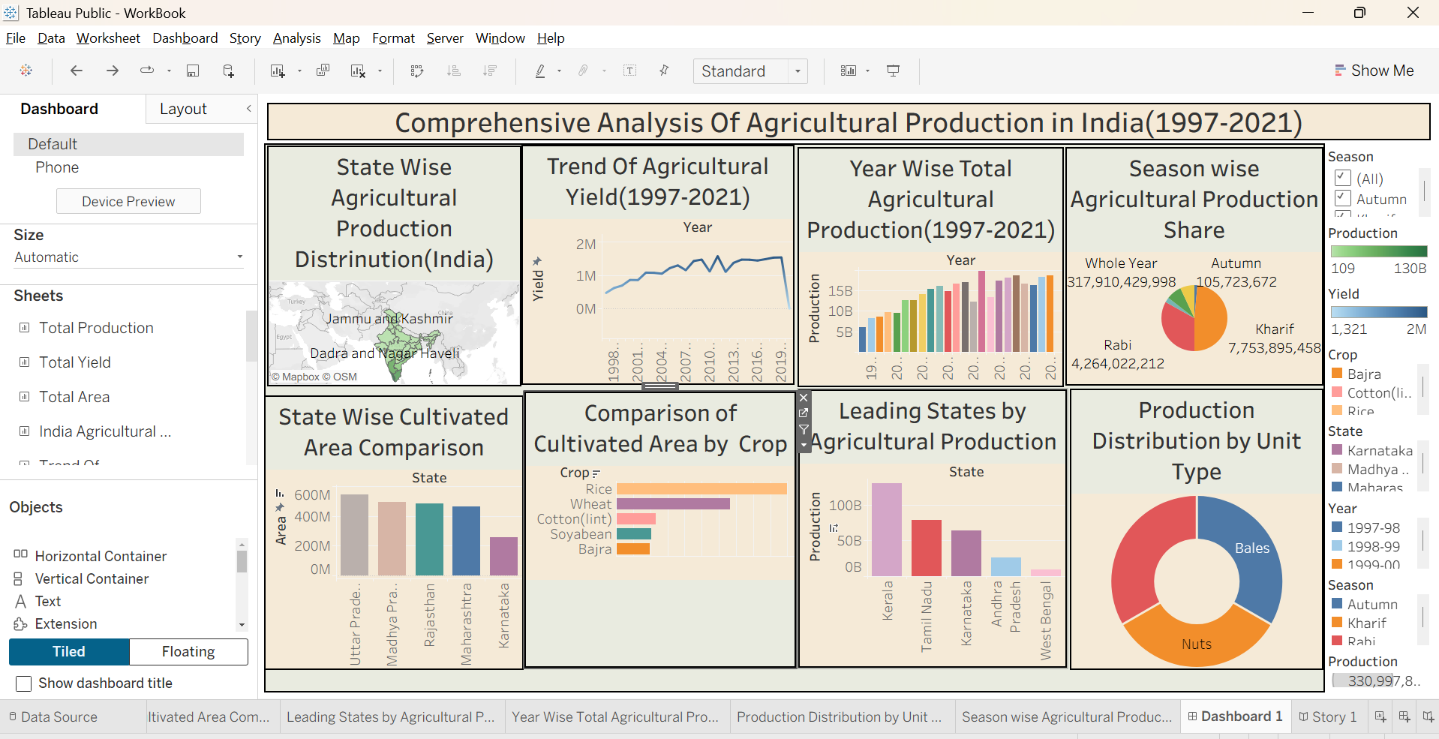
Note: Highlight the major outcomes in form of bullet points
Major Outcomes
- Total Production and Total Yield: KPI cards provide a quick overview of India's agricultural production.
- State-wise Production: Karnataka has the highest total production in the analysis.
- Cultivated Area: Uttar Pradesh leads with approximately 542.67 million hectares, followed by Madhya Pradesh, Rajasthan, and Maharashtra.
- Crop Analysis: Rice and wheat are prominent in northern states, while cotton and soyabean are important in central and western regions.
- Season Analysis: The dashboard helps compare agricultural production across different seasons.
- Year-wise Trend: The line chart shows changes in agricultural production from 1997 to 2021.
- Interactive Filtering: Users can select State, Crop, Season, Year, Production, and Area to perform detailed analysis.

Activity 2
The completed dashboard was published on Tableau Public so that users can access and interact with the agricultural analysis online.
Example
https://public.tableau.com/app/profile/vishal.bade6689/viz/WorkBook_17870655561870/Dashboard1?publish=yes

